3:30-3:45 **Warmer**: snap clap

* Leader starts by doing a sound- then calls on a person. That person repeat and adds their own sound then calls on the next person. You can also say a word if you don’t want to add a sound.
* Example- Bob: SNAP SNAP ‘john’ John: SNAP SNAP CLAP ‘sue’ Sue: SNAP SNAP CLAP SNAP CLAP ‘Maggie’ continue on until all people have gone.

3:45- 4:05 **Review the states and their capitol names.**

* North Dakota- Bismarck, Minnesota- Saint Paul, Wisconsin – Madison, Michigan- Lansing, South Dakota –Pierre, Iowa – Des Moines, Missouri- Jefferson city, Indiana- Indianapolis, Illinois- Springfield, Ohio- Columbus. Tell the students to get their flashcard.

Now we are going to go back in time: to before The United States was the United states.

* Ask: What are the 13 colonies? Do you know the names of the Colonies?
  + New Hampshire, Massachusetts, Connecticut, Rhode Island, New York, New Jersey, Pennsylvania, Delaware, Maryland, Virginia, North Carolina, South Carolina, and Georgia.
* Share screen of a map of the 13 colonies labeled. Go through the map and practice saying the names.
* Play this Kahoot game to practice the locations of the 13 colonies <https://kahoot.it/challenge/01263803?challenge-id=e21d906a-1678-4c6e-a9ee-5f26c1dc0f29_1611097789514>

Check out duckster and read “what is a colony?” and “why were the colonies established”

* <https://www.ducksters.com/history/colonial_america/thirteen_colonies.php>

4:05-4:20 **Game**: what colony is it? iSpy

* Use the whiteboard feature and make a fact sheet about the colonies that the whole class can see.
* Have a student pick a colony. Other students take turns asking questions and trying to guess the colony.
  + ‘Is it a southern colony?’ ‘does it have two words for its name?’ ‘Is the first letter M?’
* Tip *you may want to write some prompts down or pm kids with question ideas.*
* You can use the picture on the second page for the game

4:20-2:30 **Wrap up**

This is an extra 10 minutes to finish up any of the projects you were working on. If you are finished chat with the kids about them

* Ask about food, music, games…..

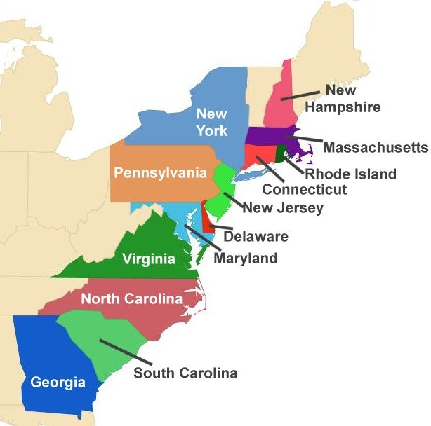

Southern Colonies

New England Colonies

Middle Colonies